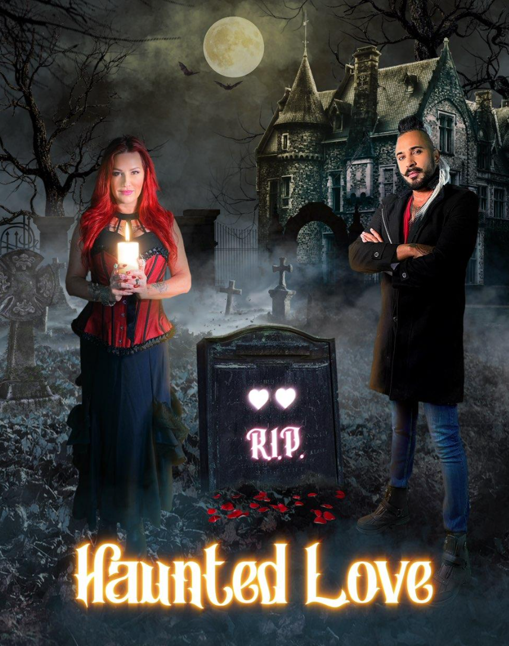

Created by
Riz & Oriah Mirza

We all know married power couples on TV are a huge hit, and in the paranormal space-we would be a unique one-of-a-kind approach. The show revolves around love stories, and Riz and I being married for 10 years on 11-11-2021, we bring our true love story and our decade of healing people with our psychic, mystic and shamanic healing skills. Riz, a psychic medium and one of the most unique and best full trance channels in the world and Oriah, a natural-born highly intuitive empath come together to help people help those who have crossed over or left a loved one behind in the living, find some resolve.

Riz, who speaks to people or spirits in other dimensions will help them move on to their next evolved place and Oriah will help the ones in the living 3D to find peace and resolve in the now help the Haunted situation, helping loved ones find peace.

The Temperament of the show: is based on true haunted love stories found in history, a true mediumship and peaceful resolve will be found for all. The show is warm and loving and healing. There will be light-hearted banter between Riz and Oriah

The Environment: The show will be filmed at night and made to feel haunted and somewhat spooky in the sense that there is unresolved torment and unrest from the unresolved love stories.

Unique Qualities: Riz and Oriah have been working side-by-side for ten years with the public and have a lot in common and both have strong personalities. Oriah loves to tease Riz and he is the more serious of the two. When Riz turns the tables on Oriah, there is no match because he is prone to surprises and cute pranks and a more focused sense of humor when he decides to be.

Aesthetic: Based on the art direction, color, interiors and feel of ‘What We Do In the Shadows’ TV Show on FX, the style is mystical manor style.

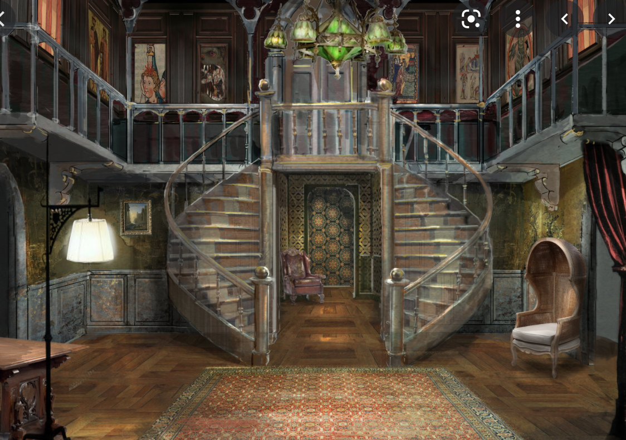
Set on What We Do In The Shadows

Intro

Origin: Oriah, born and raised in Los Angeles, CA and Riz raised in the Bronx and NYC both come from a strong 80’s influence background, love for the mystical and magical and deep commitment to love itself. Riz helping Oriah raise her five children they have not only opened a healing business that has thrived for the last ten years helping the public but have traveled extensively around the world, bringing groups of people to sacred sites.

In the beginning of What We Do In The Shadows, you see a collage of their world for the last ten years and we would like to emulate that in the opening intro. Included here is intro, photo,s and examples from the their show.

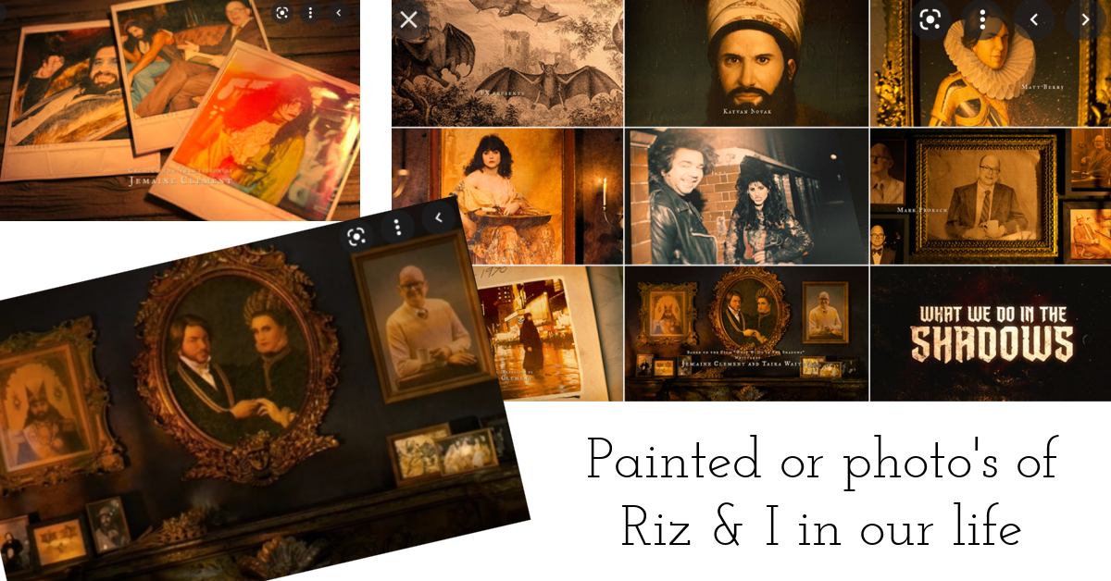

Watch the intro on What We Do In The Shadows INTRO at .20 sec
(click on image to play):
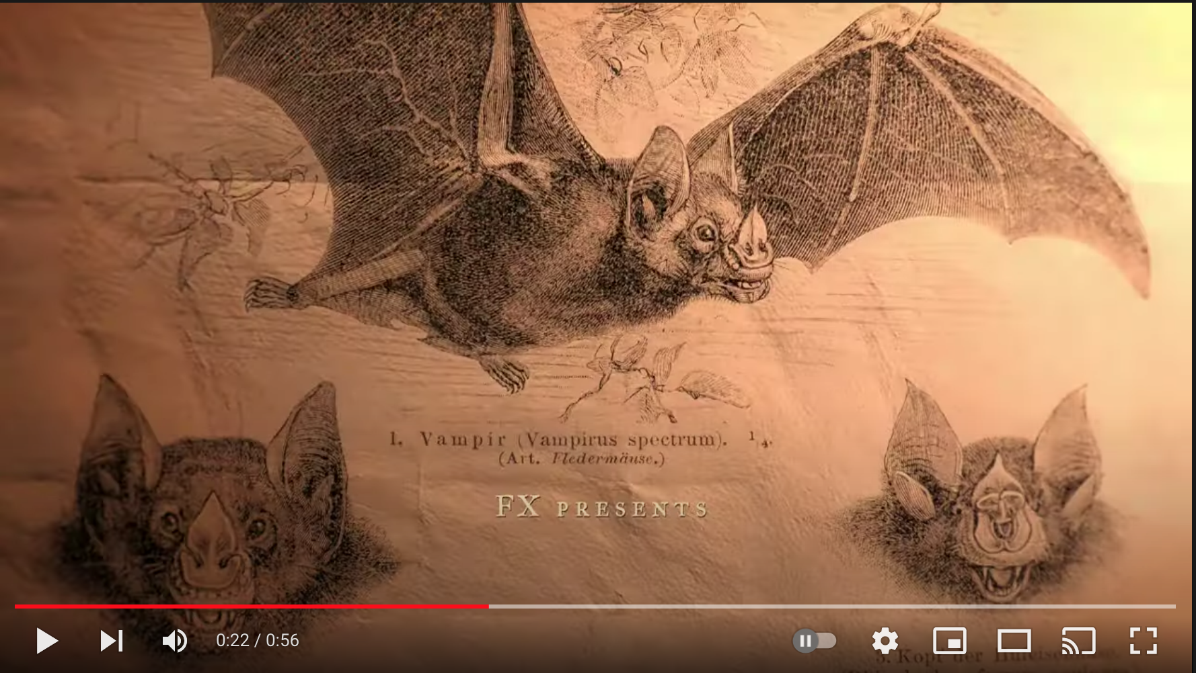

They use a lot of artwork in the show throughout the episode to show ancient vampires, etc, in our case would be the stories of the loved ones from that era.

Art Direction: Apart of our design esthetic is creating a mood and ambiance. We love the mystical, occult, lots of candles and sage and devenition tools.

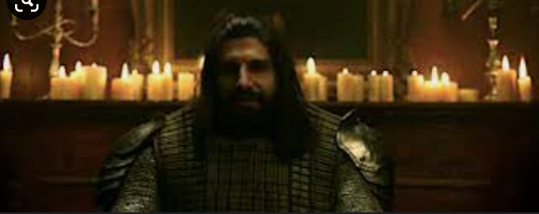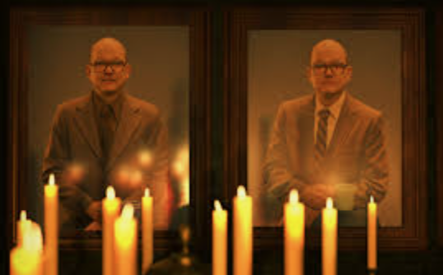
From the show…

These are some photo’s (below) from our earlier days and we literally have probably a million photos between us both showcasing so many moments in our life we can use. This was just an example. Although we like to darker mood of What We Do In The Shadows, we also want to show our love and brightness. The artwork and photo layout would be created to exemplify this.

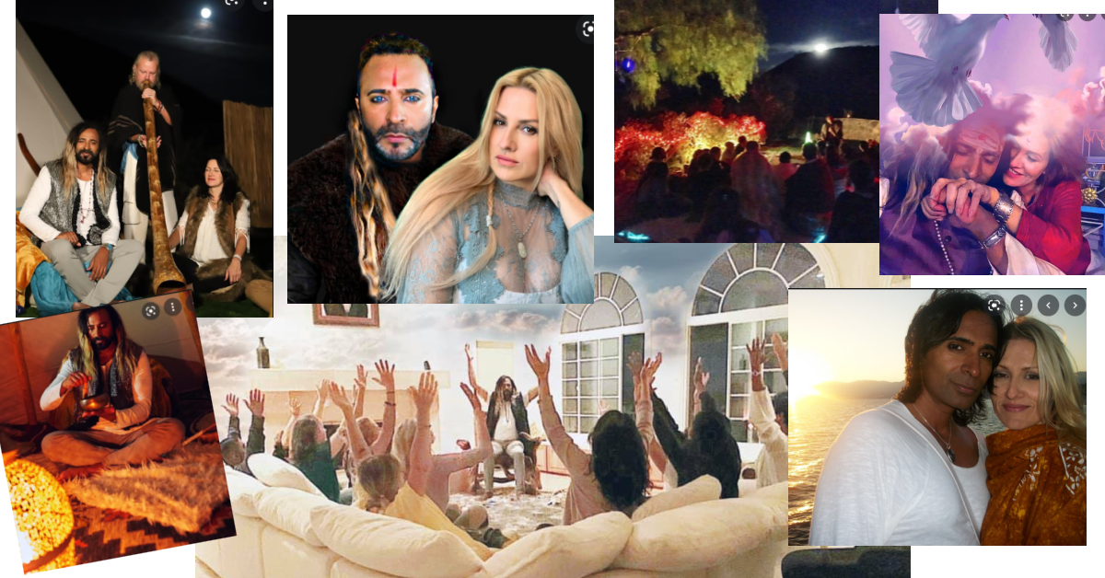

Intro Clips: 1-second video clip Moments can be shown in the intro of Riz and I in different situations from the past and present. We can showtimes before the show was filmed in our lives, and also current show moments with previous episodes we filmed.

Another Show: Cheap Old Houses
This show is based on a true-life couple who started an Instagram called Cheap Old Houses, and after showcasing many houses, they gained a huge following and now have a show on HGTV. We really liked the way they explained who the couple is, and what they do and how they do what they do. We would want a hybrid of the two shows, so the mystical element is there but the show premise is about helping loved ones who have crossed and then our work with them.

Click on the image to watch the Trailer:

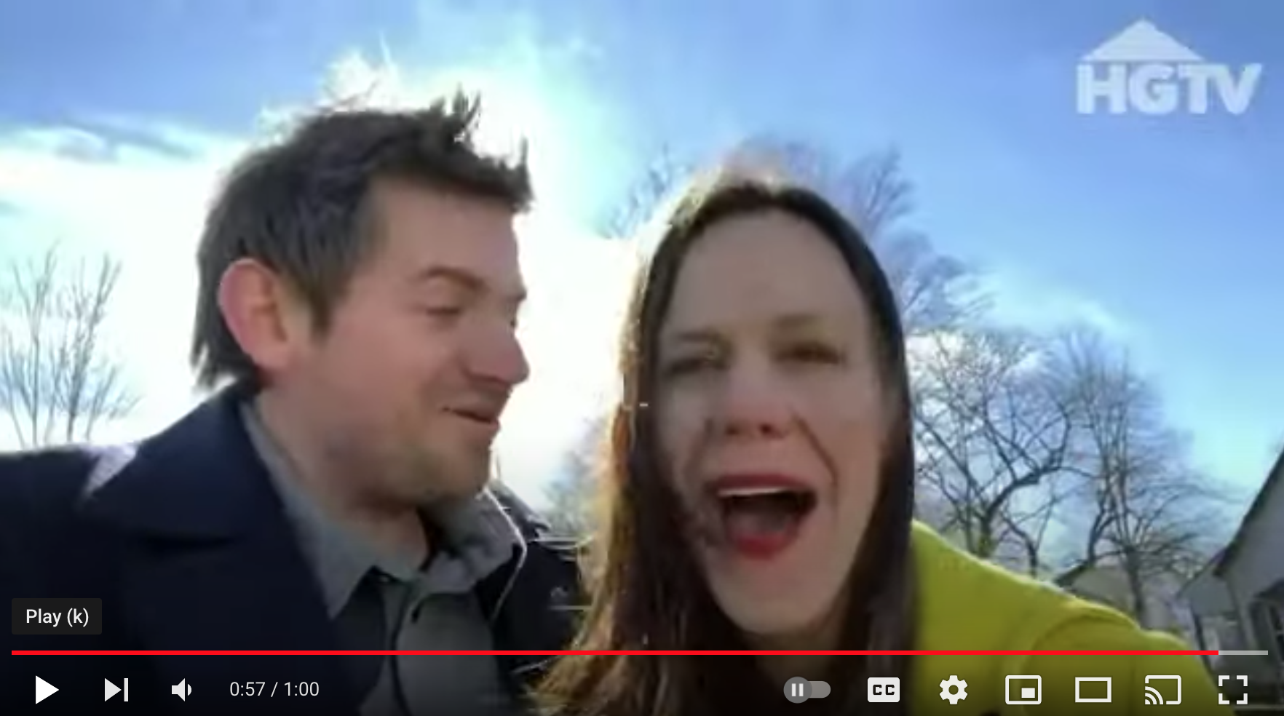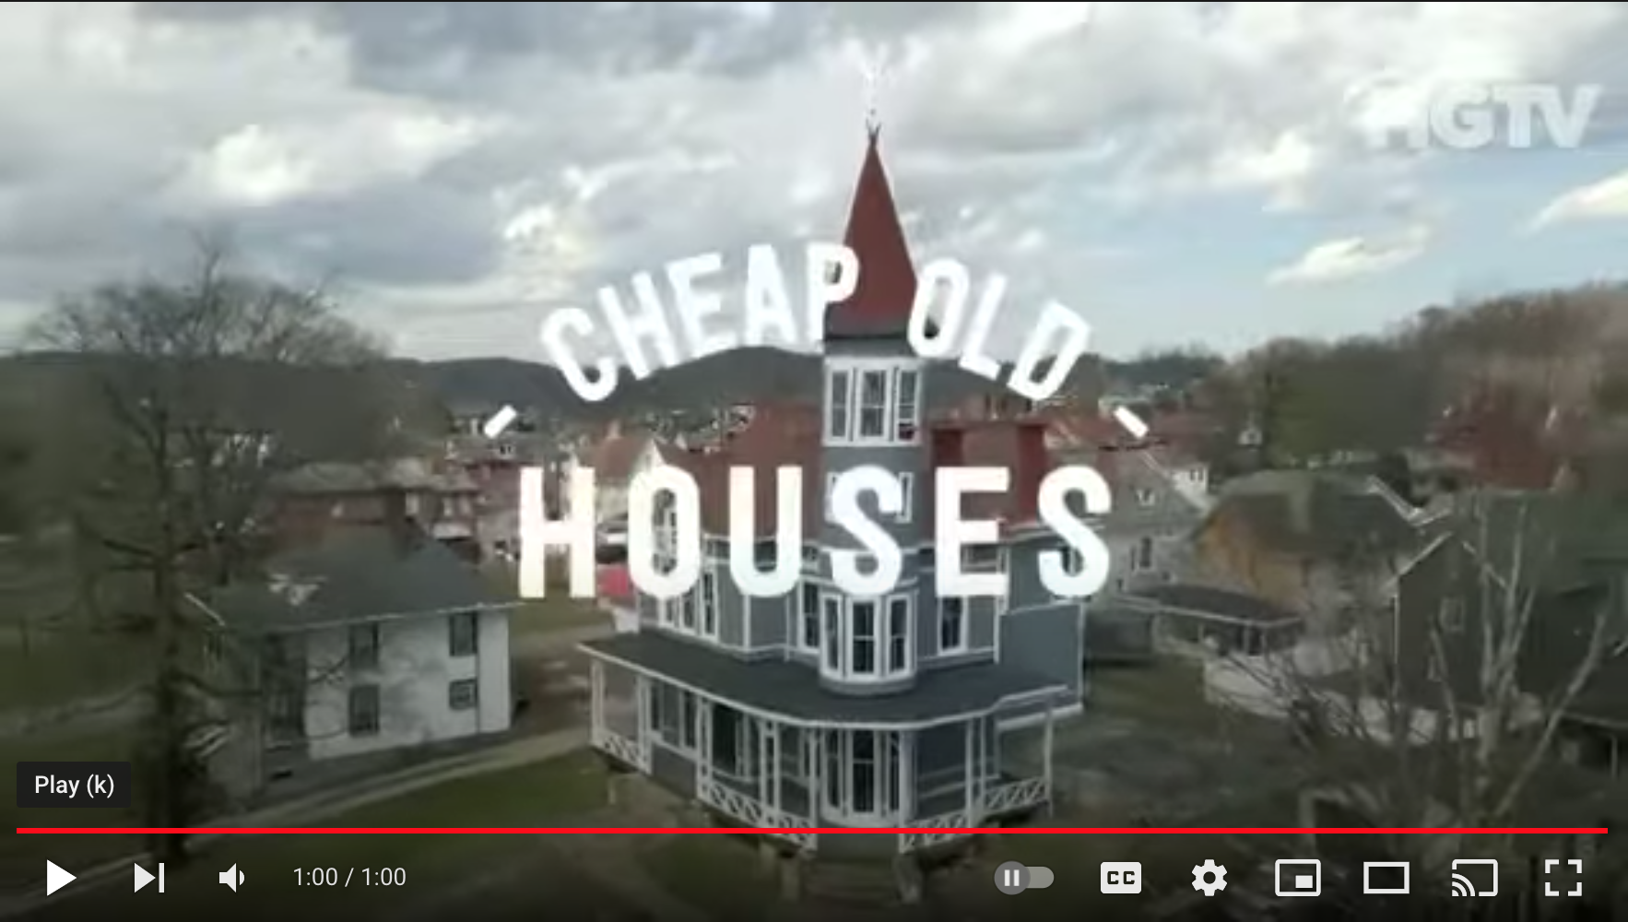

We want to drive up to the house we will be visiting in an old antique car.

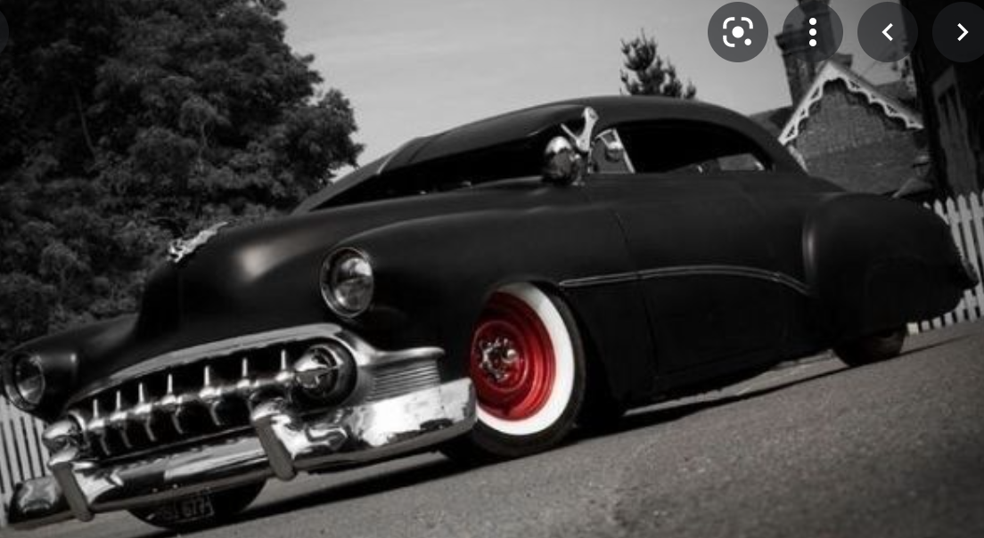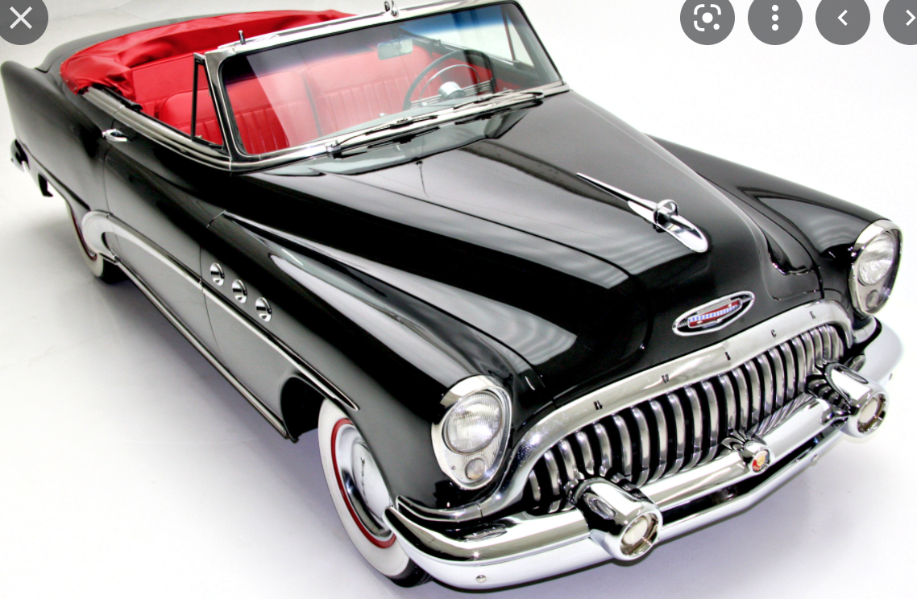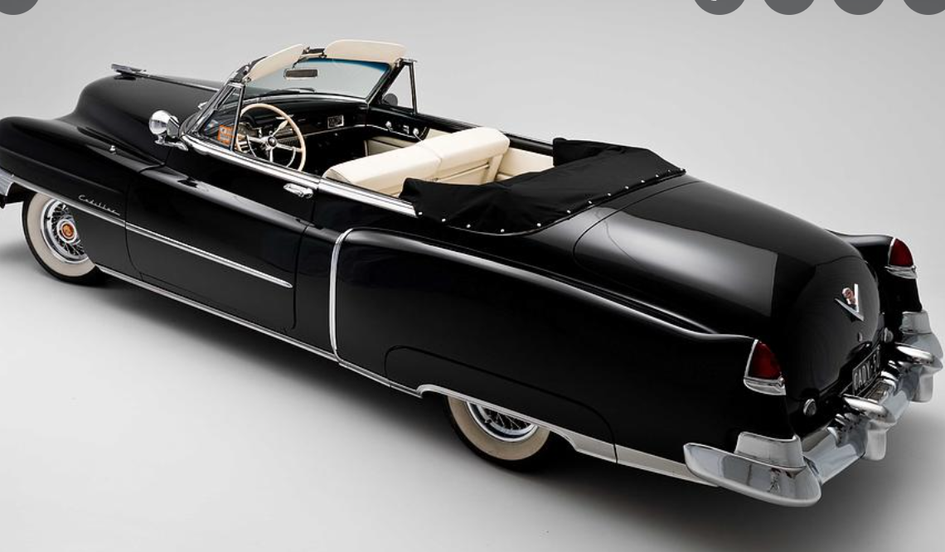

Show Premise:

There are many love stories to choose from in the US, and the world for that matter. It is easy to find:

Here’s a list:
Click on image to go to page.
These are just a few:

Ever felt a little too hung up on an ex? Cheer up, because chances are you don’t have it quite as bad as these unlucky lovers. That is, unless you were planning on spending the rest of your life (and death) sitting in a rocking chair waiting for your love to return from sea, or stuck in your bedroom sobbing for all eternity. Here are some of America’s most tragically lovesick ghosts.

Longfellow's Wayside Inn
Jershua Howe is said to still haunt the Massachusetts inn that she lived and worked in. She fell in love with a British man who promised to return to America to marry her, but she died a single woman. She had patiently waited for 44 years. She enjoys teasing the guests of the inn while she continues to wait for her long-lost love.

Governor's Mansion
In 1864 a 19-year-old boy shot himself in the head in a bedroom of the Governor’s Mansion. The woman he loved had refused his hand in marriage. For years, no one would sleep in the room because of the unexplainable banging sounds, and the room was sealed off sometime after the Civil War. In 1925 the boy’s bedroom was opened up again, and people still report hearing muffled sobs coming from the room.

Henderson State University
A young boy from what was once a Methodist college fell in love with a girl from the nearby Baptist university. Friends convinced the boy to stop seeing the girl he loved because of their different religions, and he asked someone else to the homecoming dance. When his love found out he was taking someone else, she was so distraught that she committed suicide. Students call her the “black lady,” and every year during homecoming she wanders the halls of the women’s dorms at Henderson State University, looking for the girl who stole her love from her.

Santa Clara House
A young married woman had an affair with a traveling salesman from San Francisco. When she found out she was pregnant with his child, she hung herself in her attic. The former Victorian home is now a restaurant, and customers have seen her wandering the upstairs ladies’ bathroom and staring out the window, waiting for her lover to come back to her.

Chatham Manor
The “lady in white” is said to wander along a path leading to the Rappahannock River, searching for her soul mate. Her father, an Englishman, brought her to the Chatham House in a desperate attempt to destroy her romance with a commoner. Her lover followed her to America, and the 2 planned to run away together. Their plans were discovered, the boy arrested, and the girl quickly taken back to England. The girl vowed to return to Chatham Manor to find the boy she loved. She was first seen wandering the path on June 21,1790, the day she died, and is rumored to return every 7 years on the anniversary of her death.

There are families that know a loved one (s) who have passed or just live in the historical house where it took place that experience discomfort and hauntings from that or those loved ones. Those are the house we would go into.

Reenactments: Reenactments by actors of the moment when the two lovers are separated can be interspersed throughout the episode.
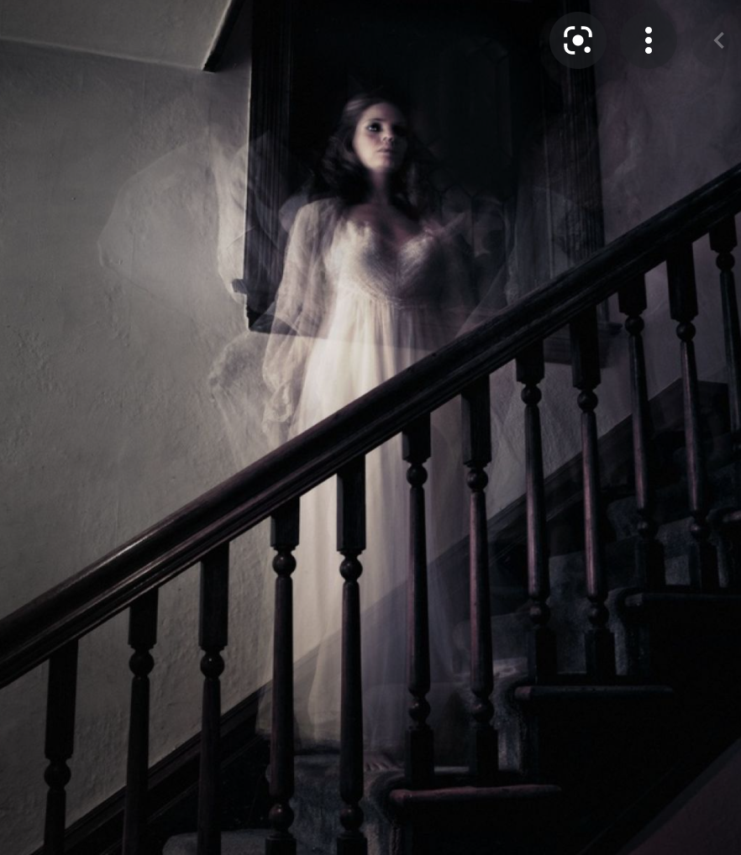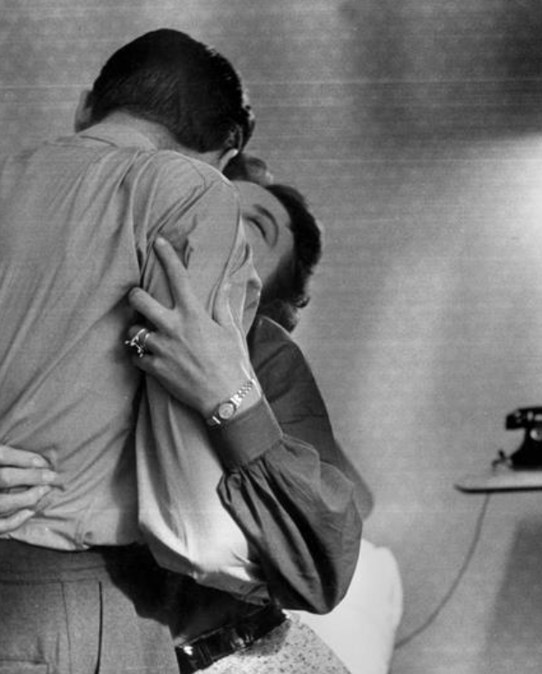
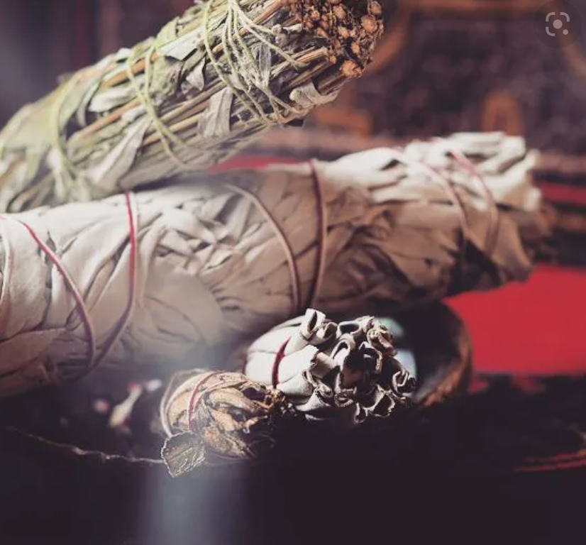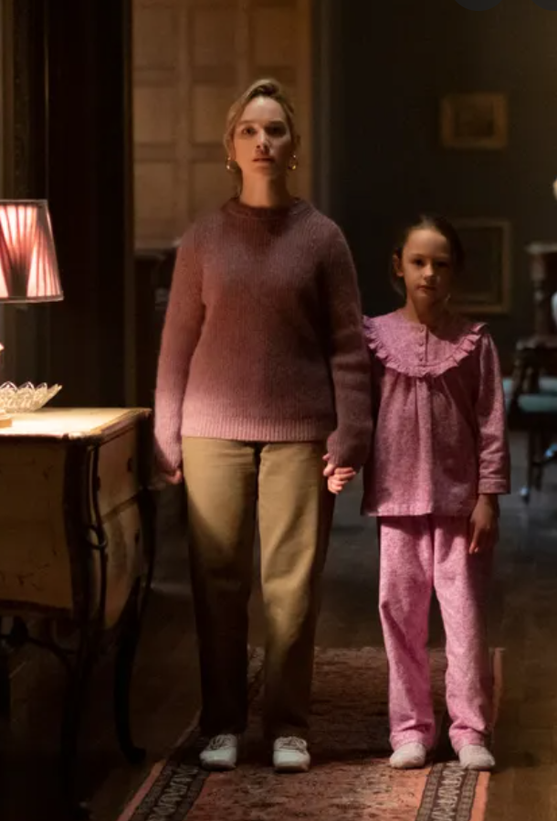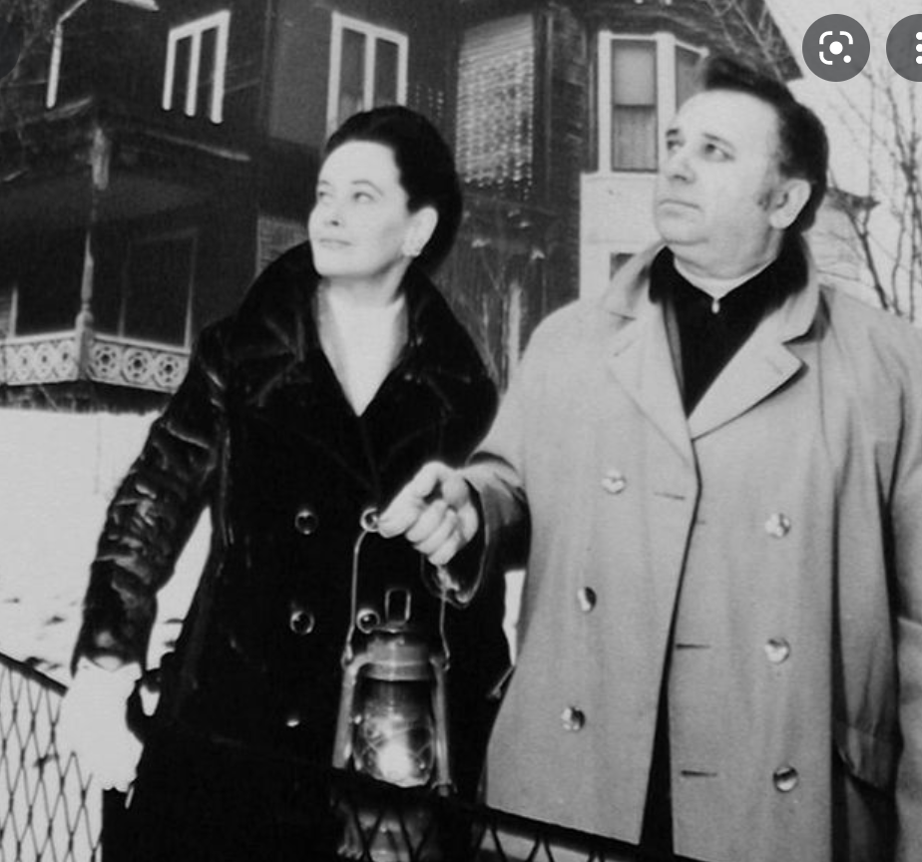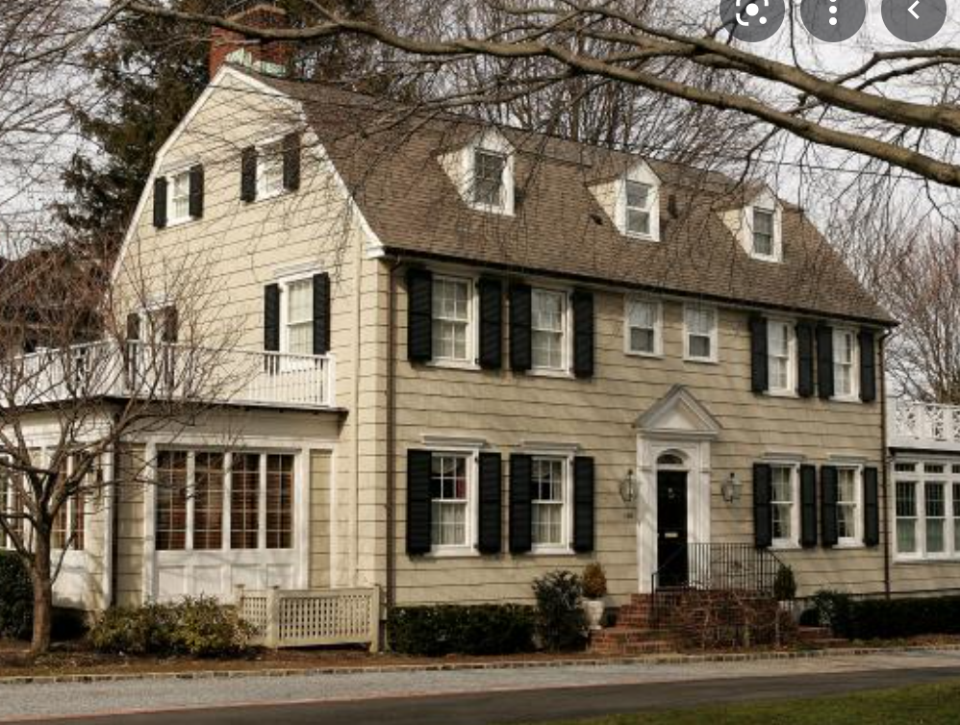

Ending:

We help bring resolution to the family or home caregiver, and there is a follow-up in 30-60 days to show that the family is happy. They do not feel the hauntings and paranormal activity anymore.

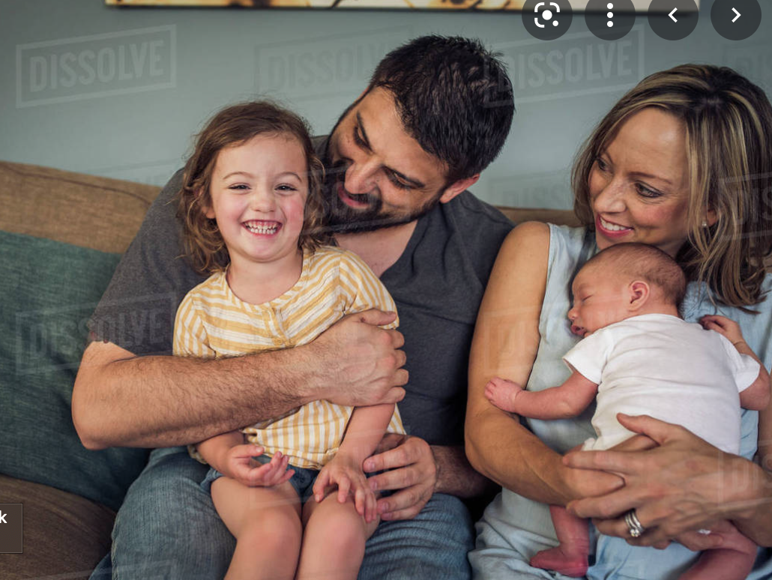

Additional Info:

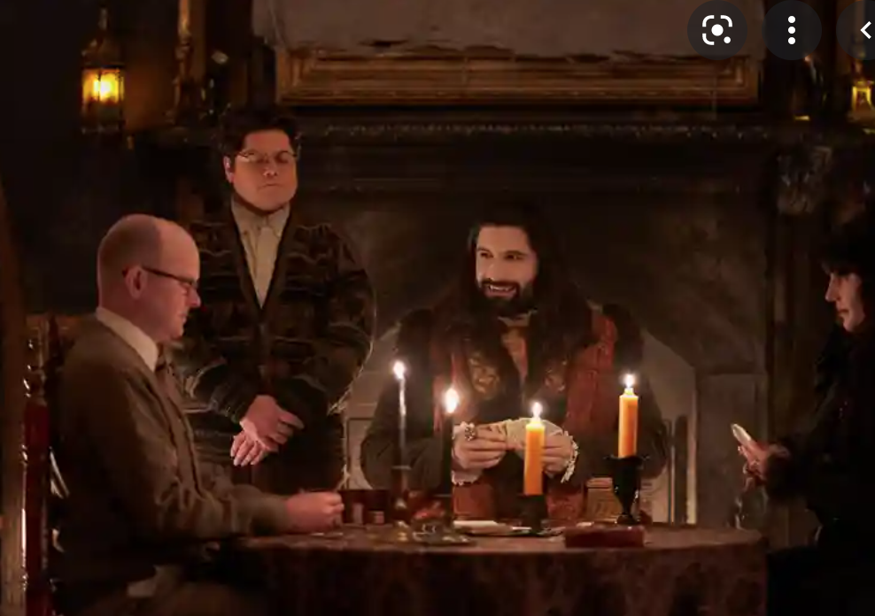
Behind the scenes (click image) to watch.

Other show concepts: Tag lines only

Riz the Wiz (based on the premise of Everybody Hates Chris except with fantasy, musical inserts) based on Riz’s childhood growing up in the Bronx and wanting to become a rockstar

Psychic Masters Competition: Riz and I host with a third psychic guest judge.

Docu-Series: Follow our journey with our grown and teenage children

“Confidential and Proprietary. Copyright (c) by Red Eagle Universal Inc. All Rights Reserved.”

